Quantifying Media Bias: Sentiment Analysis and Corpus Linguistics in Televised News Discourse
Kushaan Vardhan
Department of Computational Linguistics
Georgetown University
Krv14@georgetown.edu
Abstract
This study examines media bias through sentiment analysis and corpus linguistics, analyzing televised news discourse from major U.S. outlets using the Corpus of Contemporary American English (COCA). Traditional methods, such as manual coding and bias charts, face limitations in scalability and objectivity. By employing computational tools like VADER, this research quantifies sentiment polarity and evaluates its alignment with ideological bias ratings from sources like Ad Fontes Media. The dataset spans 1990–2019 and focuses on topics including gun control, women’s rights, and Middle East conflicts.
Findings reveal topic-specific patterns: women’s rights coverage shows a strong negative correlation between sentiment and conservative bias, while Middle East discourse exhibits a moderate positive relationship. Gun control sentiment shows no consistent bias correlation but highlights framing differences through lexical analysis. This study underscores the potential of computational approaches to enhance the understanding of media bias, offering scalable insights into the interplay of linguistic tone and ideological framing.

Introduction
The production and consumption of news media have long been scrutinized for bias, with ideological framing influencing public opinion and political discourse (Entman, 1993; Groeling, 2013). Media bias is often conceptualized through framing theory, where selective emphasis on specific aspects of issues guides audience interpretation (Entman, 2007). Traditional studies of media bias have relied on qualitative methods, such as manual coding and expert classifications, resulting in widely cited ideological bias charts (e.g., Ad Fontes Media, 2018; AllSides, 2020). However, these approaches are limited by subjectivity and a lack of scalability for large datasets, leaving room for methodological innovation.

Advances in computational linguistics, particularly sentiment analysis, offer scalable tools for quantifying media discourse. Sentiment analysis measures the polarity (positive, negative, or neutral) and subjectivity of text, providing insights into how media outlets frame political actors and events (Recasens et al., 2013; Card et al., 2015). Studies have shown that sentiment varies across ideological lines, reflecting broader divides in coverage (Horne et al., 2018). Yet, the relationship between sentiment polarity and traditional bias categorizations remains underexplored, creating a gap in understanding how linguistic tone aligns with or diverges from recognized ideological frameworks.

Corpus linguistics methods enable large-scale analysis of media language, offering a complementary perspective on bias. Leveraging extensive datasets like the *Corpus of Contemporary American English* (COCA; Davies, 2008–), researchers can examine linguistic patterns across decades of news coverage. This study combines sentiment analysis with corpus linguistics to investigate tonal differences in televised news discourse. By comparing sentiment measures from tools like TextBlob (Loria, 2014) to established bias charts, it evaluates whether tonal patterns validate or challenge existing classifications. This approach advances the study of media bias by providing a data-driven, scalable methodology to explore how sentiment encodes ideological framing in broadcast news.

Data and Corpus Construction

COCA

The study is based on the Spoken section of the Corpus of Contemporary American English (COCA), drawing from the entire available date range (1990–2019). The spoken component of COCA includes transcripts from a variety of U.S. broadcast news and talk programs, encompassing multiple television and radio networks. From this subcorpus, data corresponding to three categories of politically and socially charged topics was extracted: domestic policy (gun control), social issues (women’s rights), and international conflicts (Middle East). The corpus contains metadata identifying sources (ABC, CBS, CNN, FOX, MSNBC, NBC, NPR, PBS), so the primary analyses focus on these outlets for comparative purposes.
  - Topic Selection and Keywords

The study employed Large Language Models such as ChatGPT to aid in selection of key words based on article search popularity and topic relevance over the given time period. For domestic policy (gun control), a set of keywords reflecting different facets of firearm legislation, rights, and related events was queried. These included “gun control,” “assault weapons ban,” “second amendment,” “NRA,” “gun legislation,” “gun reform,” “Brady Bill,” “firearm,” “gun rights,” “gun show,” “gun violence,” and “mass shooting.” For the social issue (women’s rights) category, we chose search terms that capture longstanding debates over policy, equality, and workplace issues: “abortion,” “equal pay,” “feminism,” “gender discrimination,” “gender equality,” “glass ceiling,” “metoo,” “pay equity,” “reproductive rights,” “sex discrimination,” “title IX,” and “women’s rights.” Finally, for the foreign policy (Middle East-related) content, we included keywords related to major conflicts, figures, and events: “Afghanistan war,” “Bin Laden,” “Gulf war,” “Sadam Hussein,” “Iraq war,” “ISIL,” “ISIS,” “Islamic State,” “Operation Desert Storm,” “Al Qaeda,” “Taliban,” “War in Afghanistan,” “War on Terror,” “Weapons of Mass Destruction,” and “WMD.”
These queries were run separately against the spoken COCA, yielding a set of .txt files—one per query—each containing concordance lines (up to 50 words before and after the target keyword), along with metadata specifying the media source.

  - Data Aggregation and Formatting
The extracted data for each query were combined into a single .csv file. This final dataset included the text snippets, their associated sources, and query terms, enabling a unified analysis. We recorded only the source-level metadata (e.g., ABC, PBS, FOX, CNN, etc.), which allowed us to later filter and compare different outlets.

Bias Ratings and AdFontes Media

In order to compare sentiment measures with known media bias ratings, bias scores from Ad Fontes Media, a recognized organization that evaluates news sources based on political bias and reliability, were obtained. These ratings are derived through a rigorous methodology involving both human-annotated assessments and content analysis (Otero et. al 2024). By anchoring our sentiment analysis against these established bias metrics, we can assess whether sentiment correlates with recognized ideological placements.
- Methodology
This section details the computational methods used to analyze sentiment, integrate media bias ratings, and assess their relationship through multiple statistical tests.
  - Sentiment Analysis and Scores
The study employed the VADER (Valence Aware Dictionary and sEntiment Reasoner) tool to measure sentiment polarity within each text snippet. VADER is lexicon and rule-based, designed to handle social media and conversational text, making it adaptable for spoken transcripts. Each line containing a target keyword from our queries was processed through VADER to obtain a compound sentiment score in the range [-1, 1], with negative values indicating negative sentiment, positive values indicating positive sentiment, and values near zero denoting neutral content.
The study then averaged the sentiment scores for each source, focusing on a core set of outlets for comparison against bias ratings obtained from Ad Fontes Media. This allowed us to associate each outlet with a single mean sentiment score and a corresponding bias score.
  - Comparing Sentiment and Bias
To test whether sentiment corresponded to known bias scores, the study first computed the Pearson correlation coefficient, a standard measure of linear association. Recognizing the possibility that relationships might not be strictly linear or could be influenced by small sample sizes, the study also included Kendall’s Tau and Spearman’s rank correlation. Both Kendall’s Tau and Spearman’s rank correlation assess monotonic relationships and are less sensitive to non-linearities, outliers, or the particular distribution of the data. By examining all three metrics—Pearson’s r, Kendall’s τ, and Spearman’s ρ—we gained a more robust understanding of how sentiment might (or might not) align with ideological leanings.
  - Supplemental Analyses
In the supplemental analysis, the study extended beyond global sentiment averages to a more granular lexical framing approach. For each source in the gun control subset of our data, we identified words that frequently co-occur with the various gun-related queries (“gun control,” “NRA,” “assault weapons ban,” etc.) and calculated the average sentiment of the lines in which these words appear.
This per-source, per-word analysis provides a nuanced view of how different outlets may frame the debate. While certain sources may not differ dramatically in their overall sentiment scores, the words they consistently use in connection with gun-related topics can reveal underlying ideological leanings. For example, a source might frequently pair gun-related terms with language connoting “rights,” “freedoms,” or “constitutional protections,” resulting in a set of collocates that cluster around a particular sentiment range. Another source might highlight “violence,” “death,” or “public safety,” leaning toward a different sentiment spectrum.
By examining which words appear in more positive-sentiment contexts and which cluster in more negative ones, we observe that even when global sentiment-to-bias correlations are weak, the lexical environments in which these topics are discussed can reflect subtle framing differences. These differences offer a more complex lens through which to understand ideological bias, suggesting that future models could combine sentiment scoring with collocation-based framing indicators to achieve a deeper understanding of media discourse.
- Results
See Appendix A for figures (1-3) and table (1).

Analysis
This section examines the results for each thematic domain—Women’s Rights, Middle East, and Gun Control—comparing sentiment scores against bias ratings and interpreting the significance of the observed relationships. Where direct correlations prove inconclusive, we delve into more nuanced lexical analyses.

Women’s Rights (Figure 1)
For the Women’s Rights dataset, the correlation metrics indicate a strong, statistically significant negative relationship between sentiment and bias. The Pearson correlation is -0.63, suggesting that as media sources become more ideologically right-leaning (higher bias scores), their sentiment toward women’s rights topics tends to be more negative. Non-parametric tests reinforce this finding: Kendall’s Tau is -0.79 (p < 0.006) and Spearman’s Rank correlation is -0.90 (p < 0.003). The consistency across all measures implies a steady monotonic trend, not merely a linear one. In other words, outlets considered more conservative consistently show more negative sentiment toward women’s rights issues, while more liberal or centrist sources exhibit relatively more positive or neutral sentiment. These results align intuitively with public debates and partisan divides on topics such as reproductive rights, equal pay, and workplace discrimination.

Middle East (Figure 2)
Contrasting with the Women’s Rights domain, coverage of Middle East topics shows a moderate but positive and significant association between sentiment and bias. The Pearson correlation (~0.50) indicates that as certain sources lean more toward the right, the sentiment in their discourse about the Middle East becomes somewhat less negative (or marginally more positive). Non-linear tests confirm the trend: Kendall’s Tau (~0.71, p < 0.02) and Spearman’s Rank correlation (~0.81, p < 0.02) both suggest a strong monotonic pattern. While the reason for this positive relationship may be less intuitive, it could reflect how certain outlets frame foreign policy or conflict scenarios—some ideological positions may emphasize nationalism, unity, or strategic successes, resulting in relatively more positive language even when discussing war, terrorism, or geopolitics.

Gun Control (Figure 3)
In the Gun Control dataset, simple sentiment-to-bias correlations are inconclusive. The Pearson correlation (-0.58) and non-parametric measures (Kendall’s Tau ~-0.29, Spearman’s ~-0.43) do not achieve statistical significance. Despite moderate absolute values, p-values remain high, indicating no reliable linear or monotonic relationship. Thus, sentiment alone fails to differentiate between sources with distinct ideological positions on gun-related topics.
This absence of clear correlation prompted a deeper examination of lexical framing. We conducted a collocational analysis of the words appearing frequently in the context of gun control queries, associating each word with the average sentiment of lines in which it appears. Table 1 distills this extensive analysis into a concise selection of words. Each source reveals distinct lexical patterns: for instance, some right-leaning outlets frequently mention terms like “great” or “kind” in positive-sentiment contexts, whereas others associate “crime” or “death” consistently with negative-sentiment lines. This divergence in framing words suggests that while sentiment scores alone do not map neatly onto bias ratings, the linguistic environment surrounding gun control topics might still reflect ideological stances. Certain outlets highlight aspects related to crime, enforcement, and victims, pulling sentiment downward, while others emphasize leadership, agreement, or improvement, nudging sentiment upward.

Conclusion
This study contributes to the growing body of literature examining media bias by integrating computational techniques, such as sentiment analysis and corpus linguistics, to analyze televised news discourse. By leveraging a large-scale dataset from COCA and applying sentiment analysis tools like VADER, the research highlights how sentiment polarity and subjectivity metrics align—or fail to align—with established ideological bias ratings. For topics such as women’s rights, a strong negative correlation between sentiment and bias scores underscores the ideological divides in media coverage, with right-leaning outlets exhibiting more negative sentiment. Conversely, coverage of Middle East topics showed a moderate positive relationship, indicating variability in how ideological leanings influence the framing of international affairs. Gun control discussions, however, revealed no clear sentiment-to-bias correlation, suggesting that deeper lexical framing analyses may be necessary to capture ideological nuance.
These findings illuminate the complexity of ideological framing in news media, demonstrating that global sentiment scores can sometimes correlate with ideological bias but do not always provide a comprehensive picture. The supplemental lexical analysis underscores the importance of examining not only overall sentiment but also the linguistic environments in which key terms appear. This layered approach to analyzing media bias suggests that sentiment analysis, while a powerful tool, must be contextualized within broader discursive patterns to fully understand the intersection of tone and ideology in media discourse. Future research can refine these methods further, exploring additional computational tools and expanding analyses to newer forms of media, such as social platforms, to better understand the evolving landscape of ideological framing.

References
Ad Fontes Media. (2018). Media bias chart. Retrieved from https://www.adfontesmedia.com
AllSides. (2020). Media bias ratings. Retrieved from https://www.allsides.com
Andrew, G., & Gao, J. (2007). Scalable training of L1-regularized log-linear models. In Proceedings of the 24th International Conference on Machine Learning (pp. 33–40).
Augenstein, I., Rocktäschel, T., Vlachos, A., & Bontcheva, K. (2016). Stance detection with bidirectional conditional encoding. In Proceedings of the 2016 Conference on Empirical Methods in Natural Language Processing (pp. 876–885). Austin, TX: Association for Computational Linguistics.
Bonta, P., Chang, J. H., & Gupta, P. (2019). Applications of sentiment analysis in media studies. Journal of Communication Studies, 13(2), 45–59.
Card, D., Boydstun, A. E., Gross, J. H., Resnik, P., & Smith, N. A. (2015). The media frames corpus: Annotations of frames across issues. Proceedings of the 53rd Annual Meeting of the Association for Computational Linguistics (pp. 438–444).
ChatGPT. (2024). Generative AI language model by OpenAI.
Cooley, J. W., & Tukey, J. W. (1965). An algorithm for the machine calculation of complex Fourier series. Mathematics of Computation, 19(90), 297–301.
Davies, M. (2008–). The Corpus of Contemporary American English (COCA). Available at https://www.english-corpora.org/coca
Entman, R. M. (1993). Framing: Toward clarification of a fractured paradigm. Journal of Communication, 43(4), 51–58. https://doi.org/10.1111/j.1460-2466.1993.tb01304.x
Entman, R. M. (2007). Framing bias: Media in the distribution of power. Journal of Communication, 57(1), 163–173. https://doi.org/10.1111/j.1460-2466.2006.00336.x
Goodman, J., Vlachos, A., & Naradowsky, J. (2016). Noise reduction and targeted exploration in imitation learning for abstract meaning representation parsing. In Proceedings of the 54th Annual Meeting of the Association for Computational Linguistics (Volume 1: Long Papers) (pp. 1–11). Association for Computational Linguistics. https://doi.org/10.18653/v1/P16-1001
Groeling, T. (2013). Media bias by the numbers: Challenges and opportunities in the empirical study of partisan news. Annual Review of Political Science, 16(1), 129–151. https://doi.org/10.1146/annurev-polisci-040811-115123
Gusfield, D. (1997). Algorithms on strings, trees and sequences. Cambridge University Press, Cambridge, UK.
Harper, M. (2014). Learning from 26 languages: Program management and science in the babel program. In Proceedings of COLING 2014, the 25th International Conference on Computational Linguistics: Technical Papers (p. 1). Dublin City University and Association for Computational Linguistics. http://aclweb.org/anthology/C14-1001
Horne, B. D., Adali, S., & Sikdar, S. (2018). Identifying the social signals that drive online discussions: A case study of media bias and social media influence. IEEE Transactions on Computational Social Systems, 5(3), 736–748. https://doi.org/10.1109/TCSS.2018.2871507
Kubota Ando, R., & Zhang, T. (2005). A framework for learning predictive structures from multiple tasks and unlabeled data. Journal of Machine Learning Research, 6, 1817–1853.
Loria, S. (2014). TextBlob: Simplified text processing. Retrieved from https://textblob.readthedocs.io
Mamishev, A. V., & Sargent, M. (2013). Creating research and scientific documents using Microsoft Word. Microsoft Press, Redmond, WA.
Mamishev, A. V., & Williams, S. D. (2010). Technical writing for teams: The STREAM tools handbook. Wiley-IEEE Press, Hoboken, NJ.
Perplexity AI. (2024). Generative AI search engine.
Rasooli, M. S., & Tetreault, J. R. (2015). Yara parser: A fast and accurate dependency parser. Computing Research Repository, arXiv:1503.06733. Version 2.
Recasens, M., Danescu-Niculescu-Mizil, C., & Jurafsky, D. (2013). Linguistic models for analyzing and detecting biased language. Proceedings of the 51st Annual Meeting of the Association for Computational Linguistics (pp. 1650–1659).

- Figures and Tables
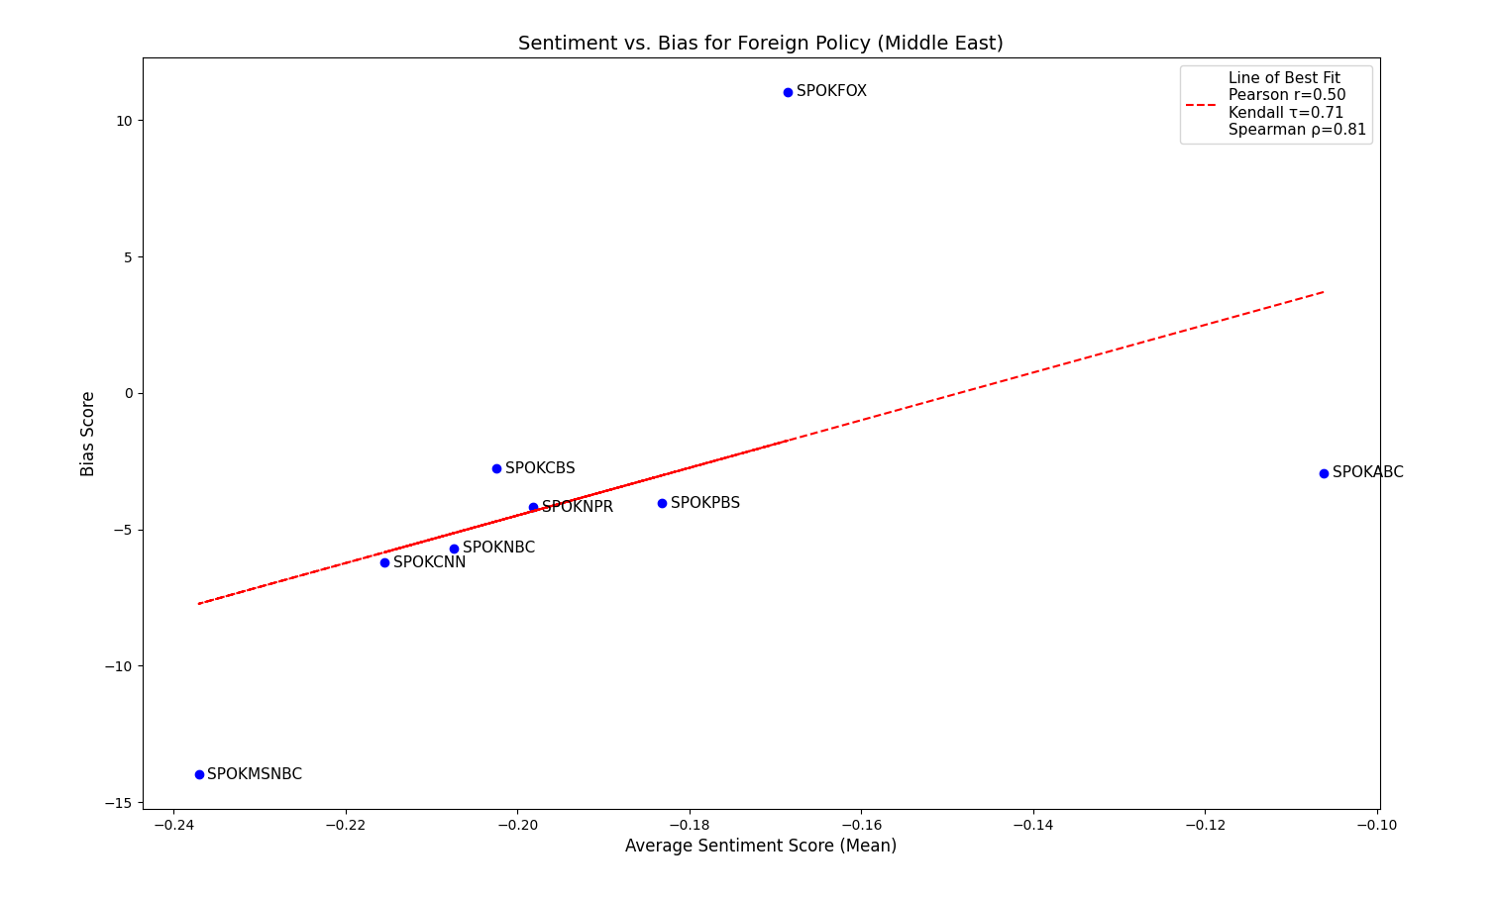
Figure 2: Graph of Sentiment vs Bias Scores (with correlation coefficients in legend) of Middle East Concordances

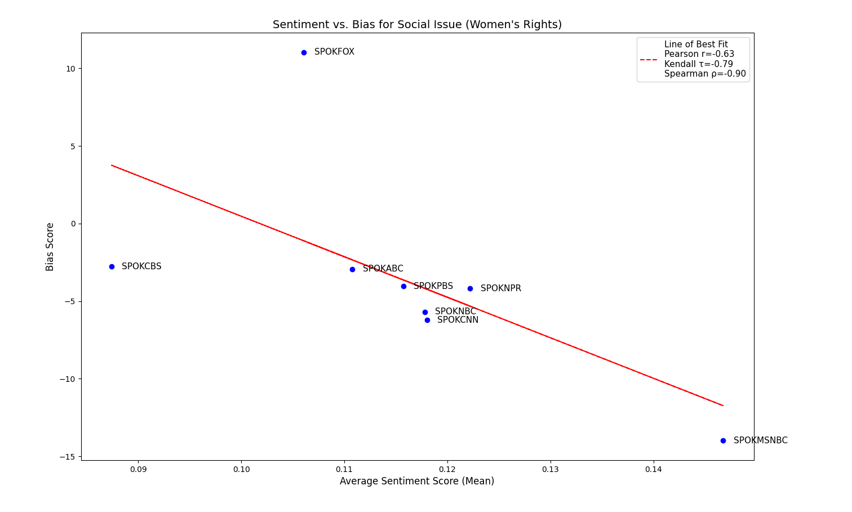
Figure 1: Graph of Sentiment vs Bias Scores (with correlation coefficients in legend) of Women's Rights Concordances

Source | High-Sentiment Words (Count, Avg. Sent.) | Low-Sentiment Words (Count, Avg. Sent.)
SPOKABC | Yes (26, 0.379), clear (27, 0.352) | Death (20, -0.746), crime (47, -0.644)
SPOKCNN | Trip (23, 0.591), sure (30, 0.352) | Violent (20, -0.787), crime (50, -0.783)
SPOKPBS | Yes (41, 0.288), court (23, 0.185) | Death (23, -0.840), killed (41, -0.833)
SPOKCBS | Great (21, 0.443), thank (36, 0.292) | Shot (20, -0.781), police (21, -0.736)
SPOKFOX | Great (43, 0.358), kind (36, 0.253) | Crime (20, -0.749), person (21, -0.706)
SPOKNBC | Big (22, 0.134), did (37, 0.132) | School (24, -0.510), look (37, -0.450)
SPOKNPR | She (25, 0.275), having (27, 0.242) | Weapon (21, -0.709), law (49, -0.607)
SPOKIndep | Think (20, 0.128), be (21, 0.035) | We (25, -0.337), he (23, -0.321)
Table 1: Condensed Collocational and Word-based Insight Table for Gun Control Data

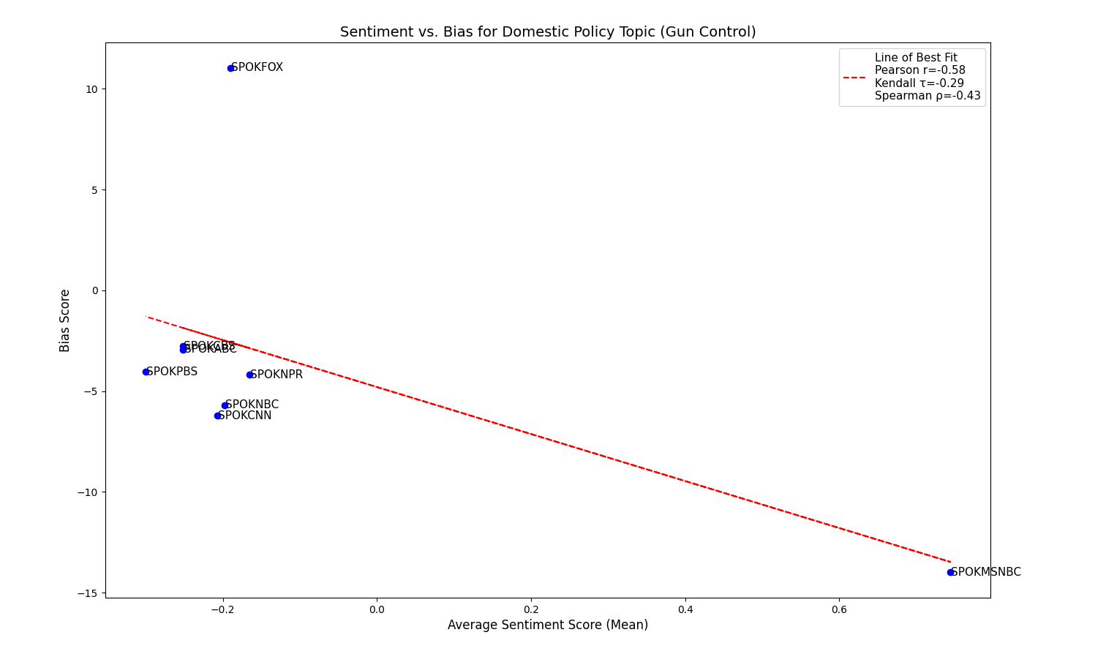
Figure 3: Graph of Sentiment vs Bias Scores (with correlation coefficients in legend) of Gun Control Concordances

